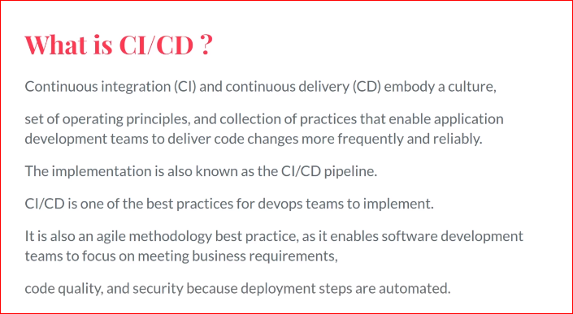

what is CI/CD...??

it is stands for

continuous integration and continuous delivery and continuous deployment embody a culture

so in Continuous Deployment everything in continous deployment is automated | everything is automated

but in Continous delivery there are one or two steps are manual | it is not fully automated | half automated | required manual steps to follow

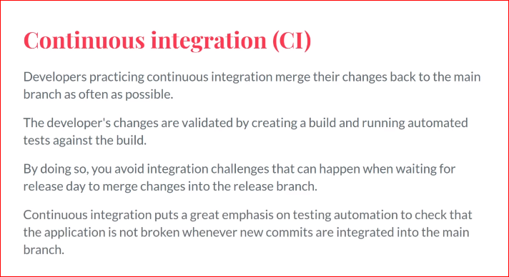

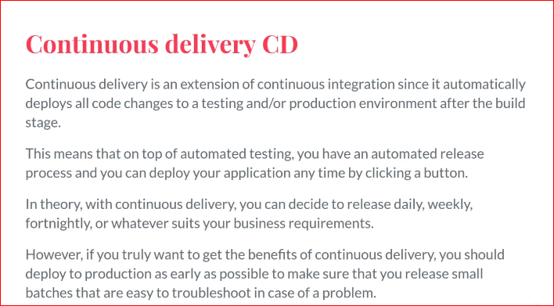

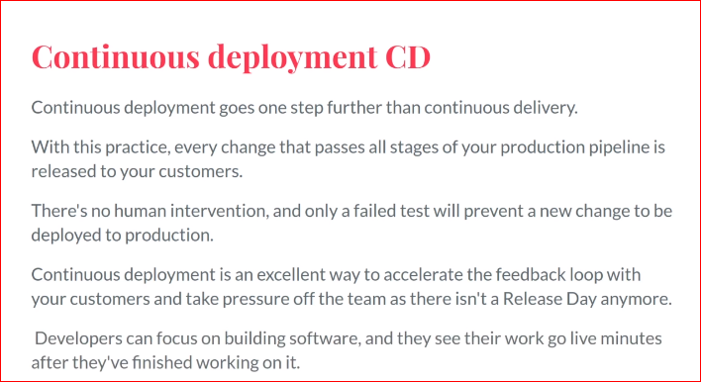

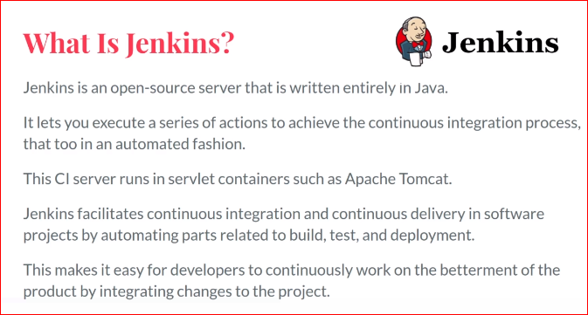

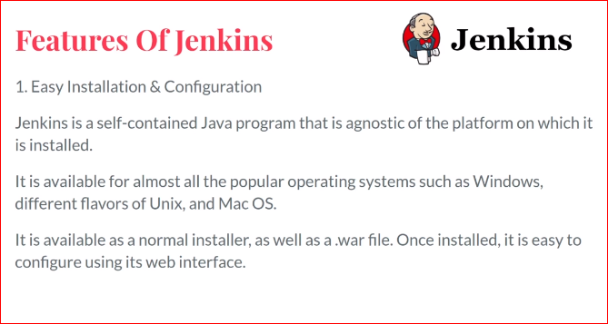

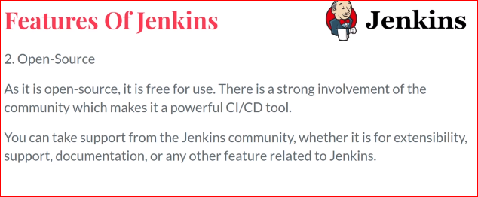

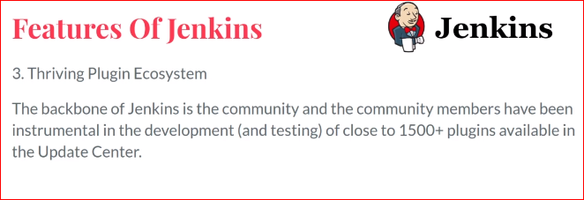

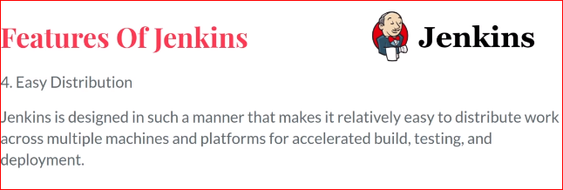

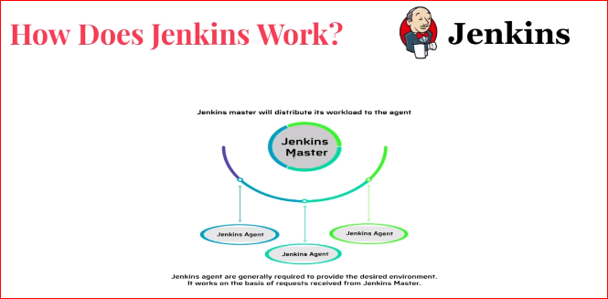

We have Jenkins master and Jenkins agents or nodes

Jenkins master distributes works to Jenkins agents

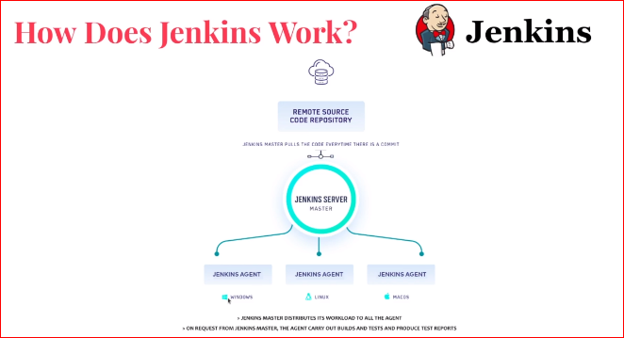

Here We have Remote source code Repository like :- github, gitLabs ,bigbucket, where we commit the code also read the image and understand this flow

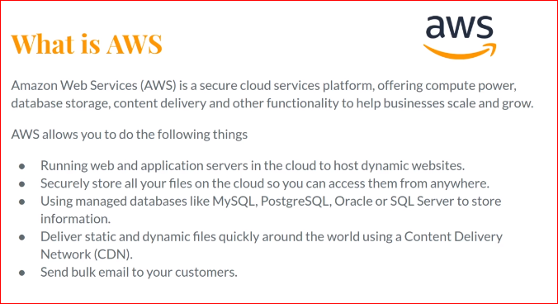

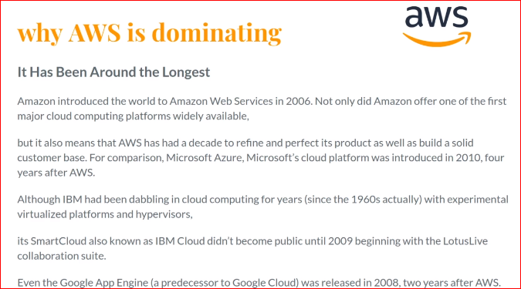

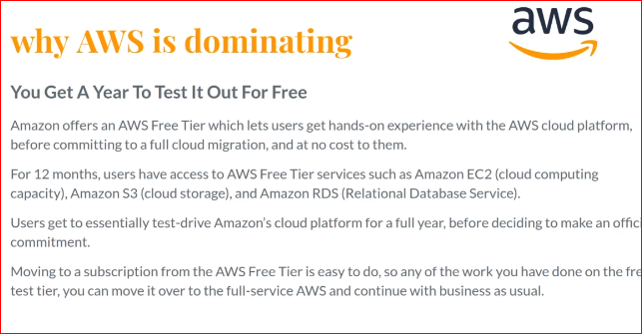

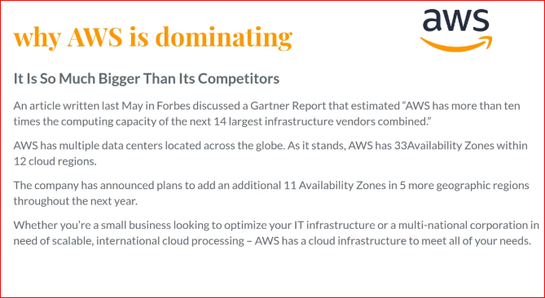

Creating Jenkins Jobs >> clickon new teams

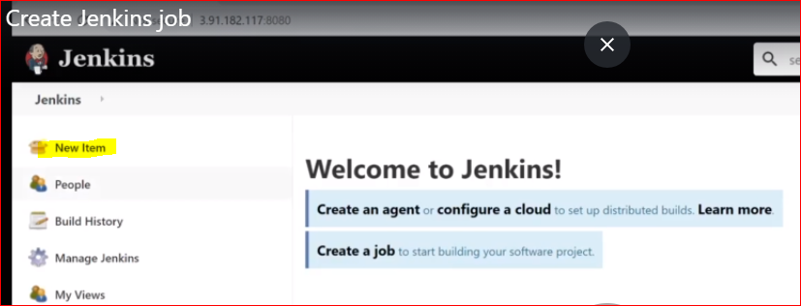

There are different types of Jobs we can create each one have own use case

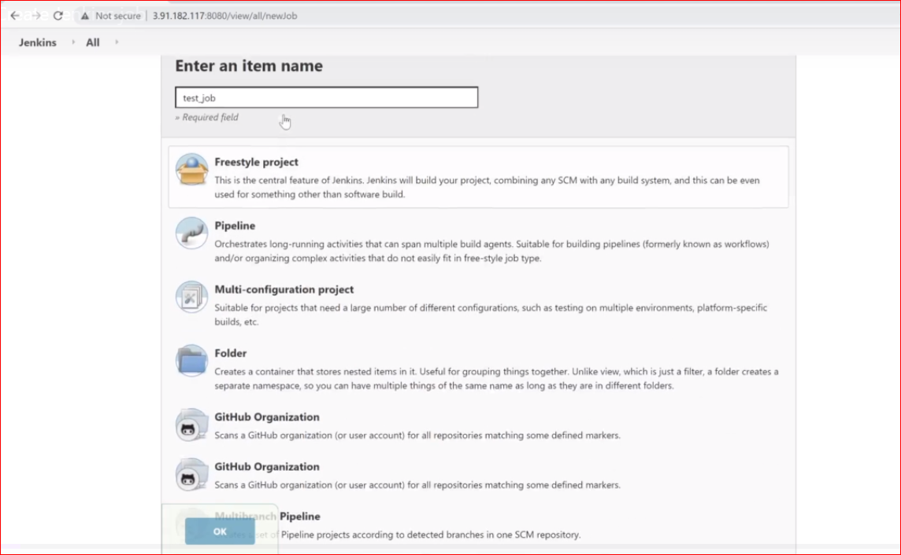

Mostly we use is freestyle project and pipeline

Freestyle project > we can customize our profile and create pipeline profile according to the configuration CHOOSE FREESTYPE PROJECT >> PRESS OK

EACH JOB HAS LIST OF tabs

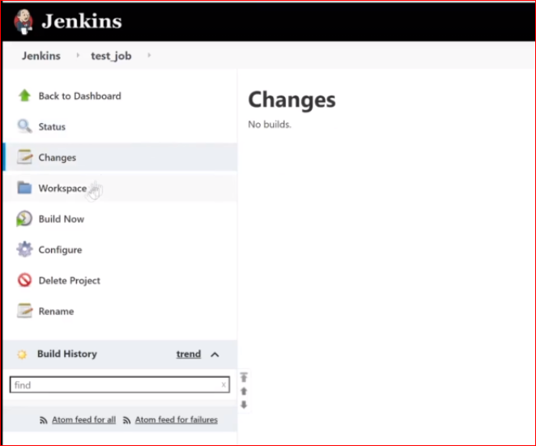

Workspace we creating on server on Jenkins node Like MASTER NODE [ JENKINS SERVER] OR REMOTE NODES LIKE :- copy file everything will be history will shows in Workspace

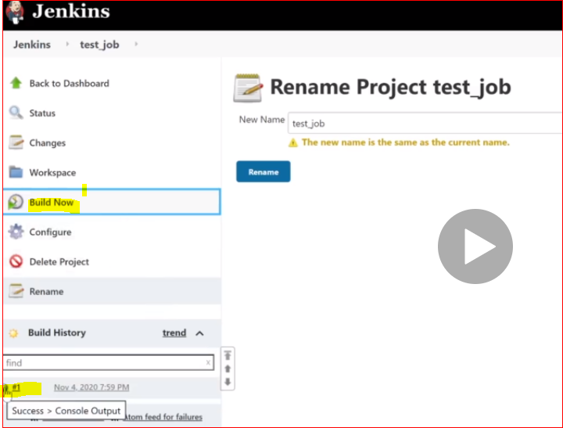

USING BUILD NOW will

Will create output file on Jenkins server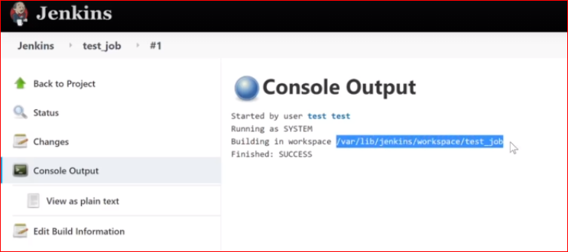

========================================== GENERAL===================================

IN CONFIGURE TAB BELOW ARE THE OPTIONS

IN GENERAL TAB WE CAN DESCRIBE WHAT WHAT JOB IS DOING

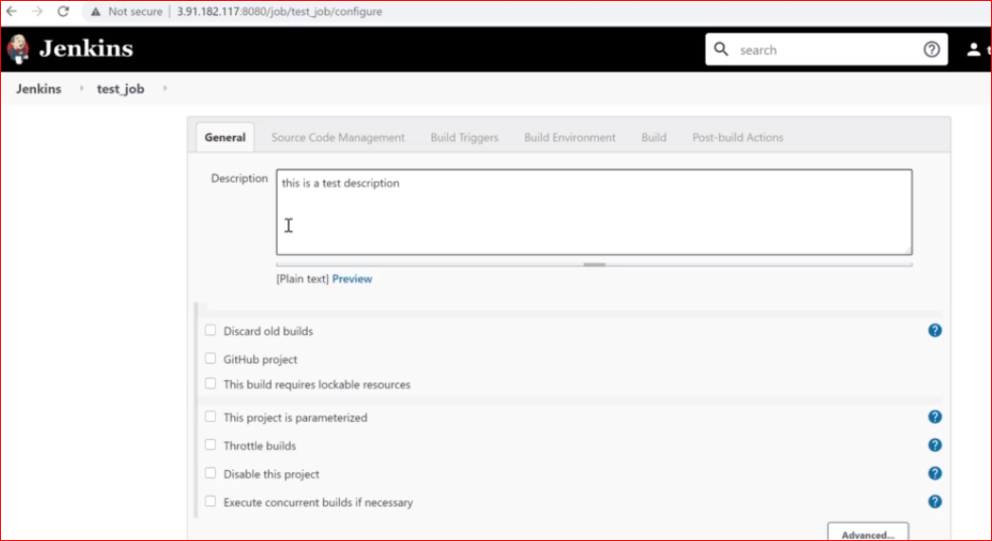

BELOW ARE THE 3 MOSTLY WE USE in general tab

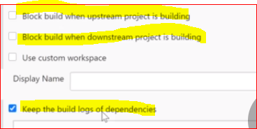

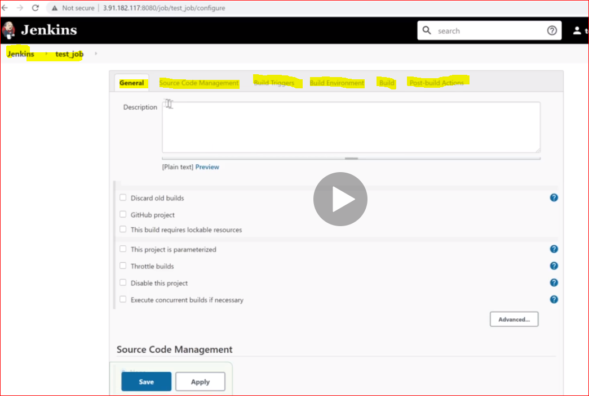

============================== SOURCE CODE MANAGEMENT==============================

CONFIGURE TAB >> SOURCE CODE MANAGEMENT >> MOSTLY USE IMPORTANCE

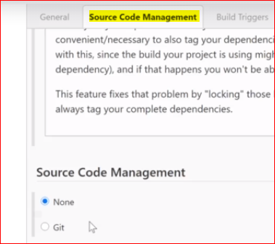

HERE we can use URL for project repo | also provide credentials >>

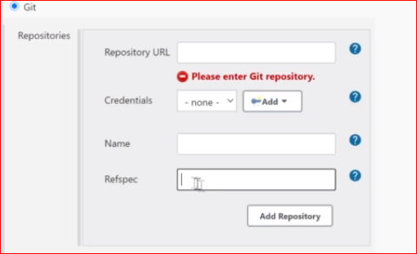

We can create multiple repositories by clicking on ADD REPOSITORY

NAME | REFSPEC >> are use for sending bulk request

We can crate multiple branches and like master | development | prod | uat | pilot

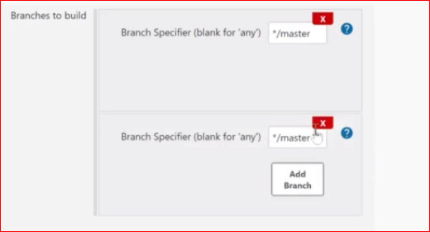

There are bunch of opetions in additional behaviours add tab menu

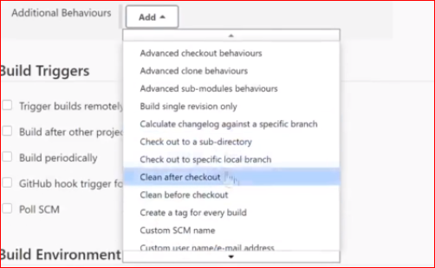

Configure >> build triggers

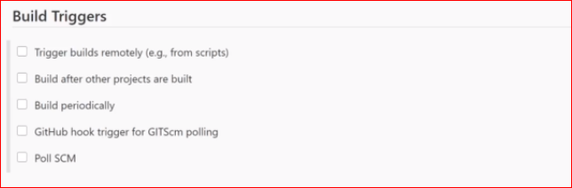

trigger current job using shell sript [ bash/ksh/powershell ] it must have access to this job

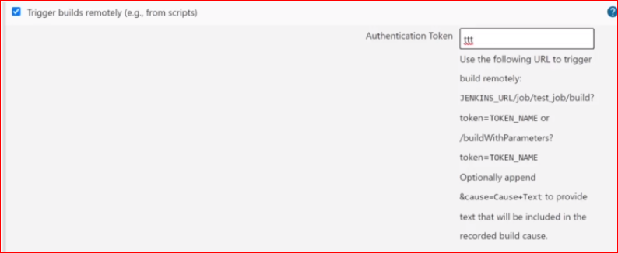

This will replace the pipeline use

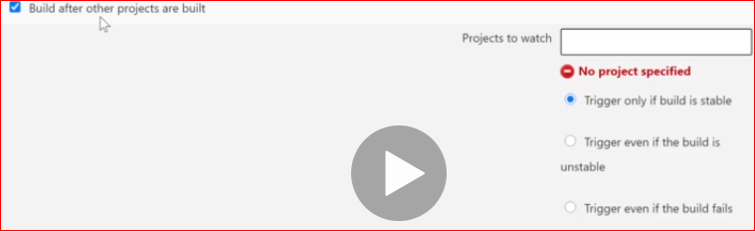

We can use old jobs to create copy of new one from old jobs

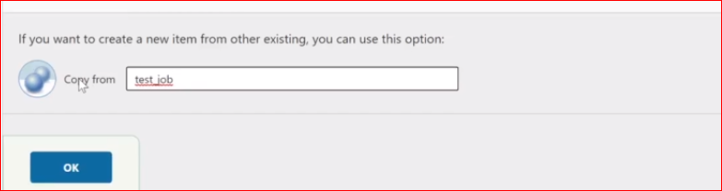

We can use old test_job and copy and use same content in new test_job_2 list and trigger here it will

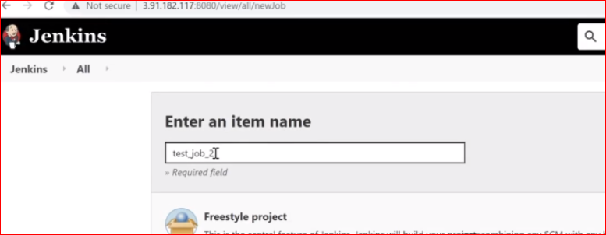

In build trggers it show all jobs in dropdown menu

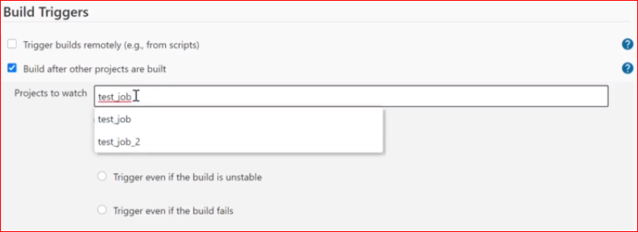

And save it

We can trigger job 1 click on circle mentioned in end of the job

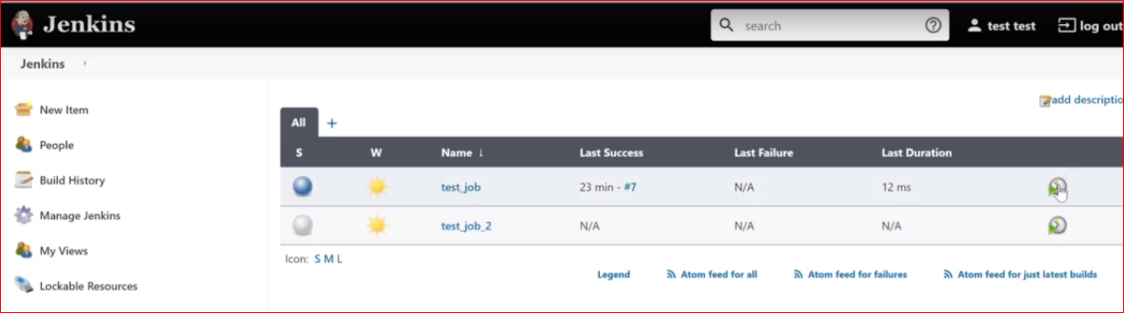

Once the test_job old job is executed successfully >> test_job 2 new job will start executing >> so for old test_job1 downstream project is test_job2

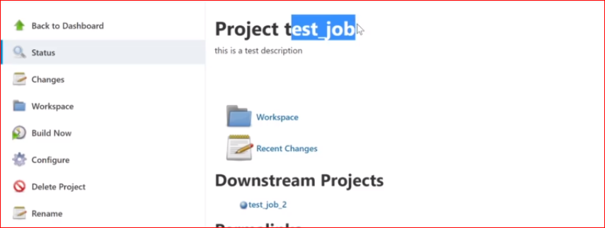

And for test_job2 theupstrem project is test_job >> this is something like pipeline

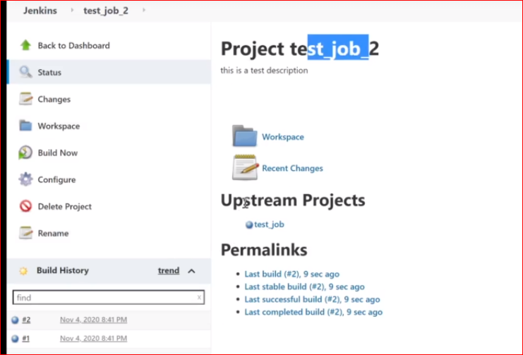

We can replace the pipeline jenkins file script or without writing any script or whatever

For here test_job2 the upstream is test_job >> we can block it by simply checking the box and

If test_job 2 is running and after test_job will not run because we have blocked the upstream. Same for dawnstream we can do..

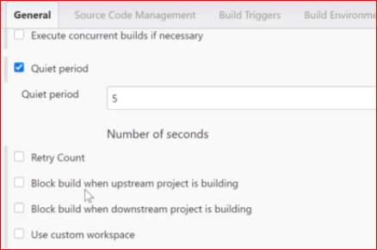

We can put crontab or cron scheduler just copy and paste or write it here click on ? for any help

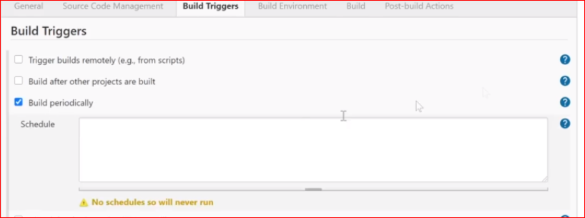

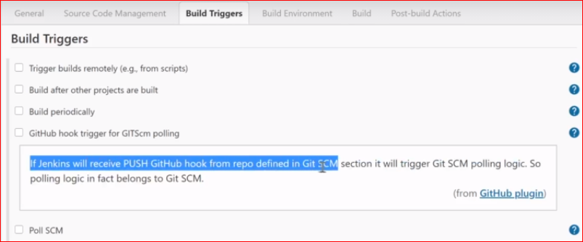

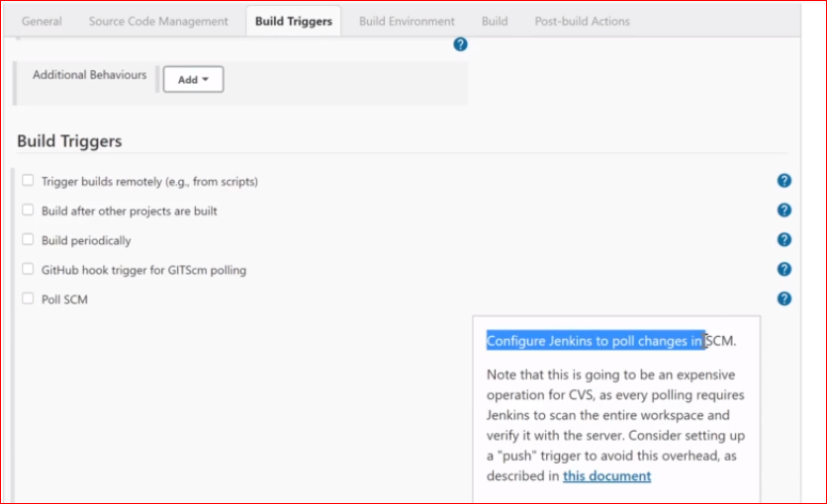

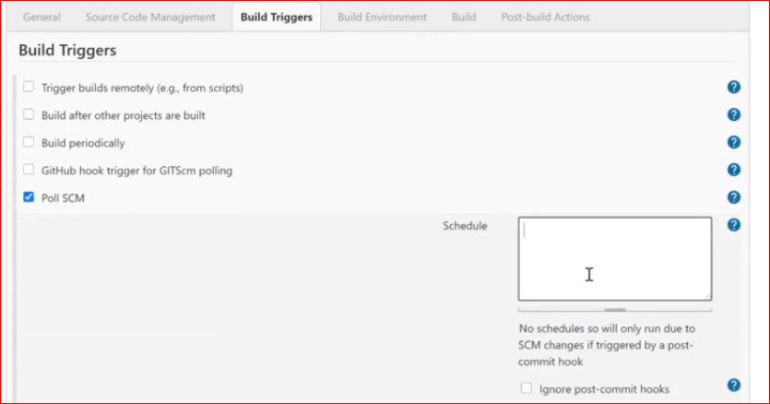

============================= BUILD ENVIRONMANT =====================================

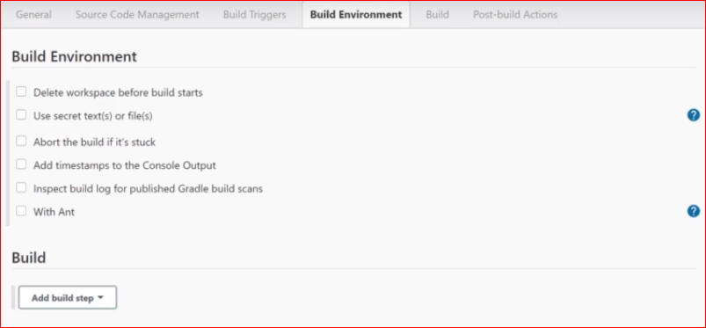

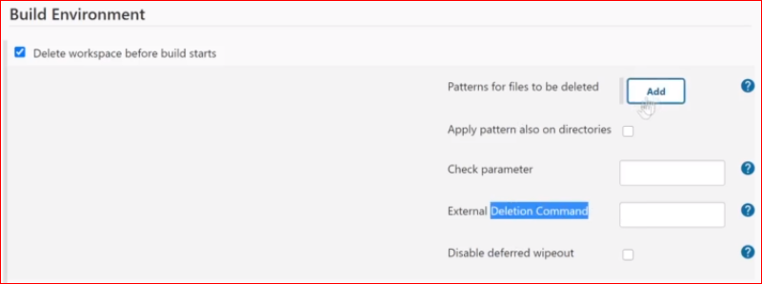

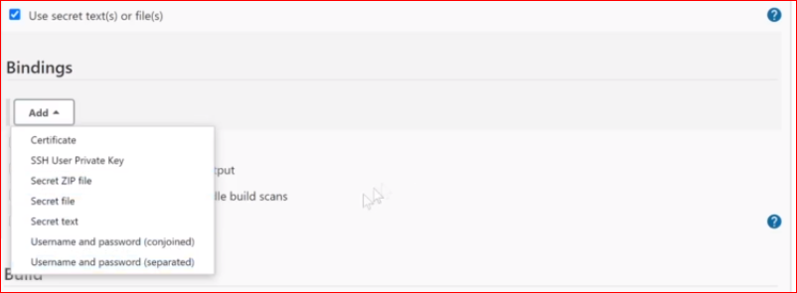

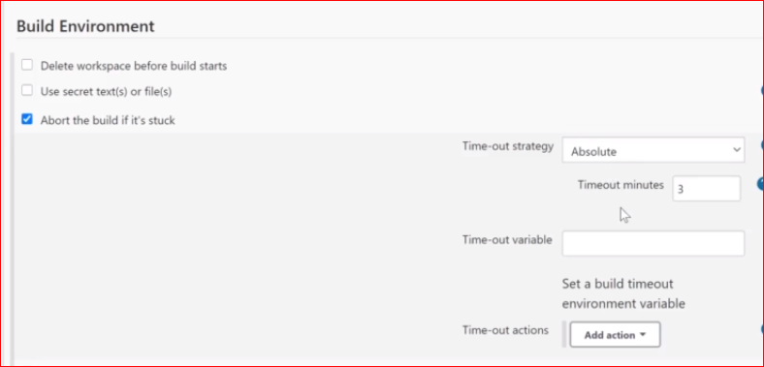

ADD TIME STAMP TO CONSOLE output if there is any error it shows time as well always check this

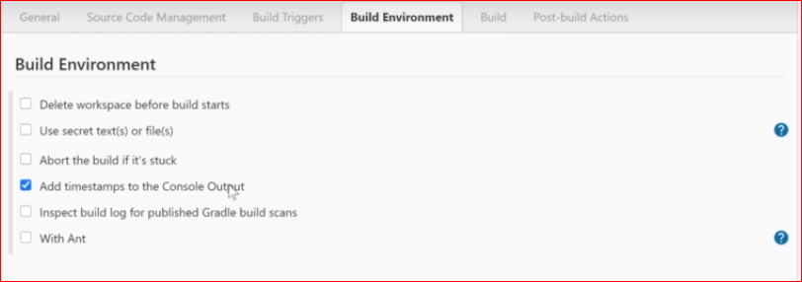

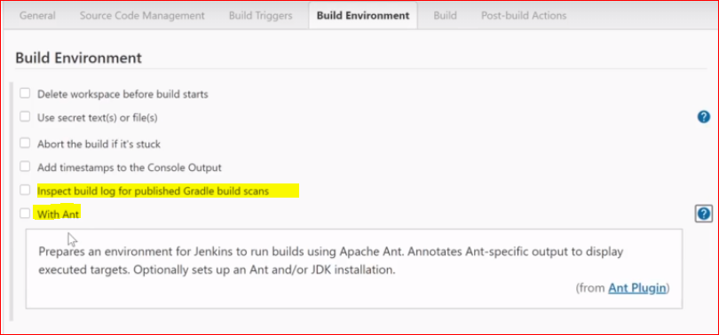

========================BUILD========================================================

I WANT this JOB test_job2 is to build actual build

This job is to deploy dependencies to build the packages that I want for specific application running and so on

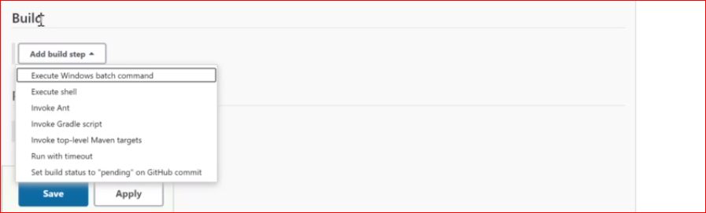

Start with selection above execute command in unix shell runn below command add in below box

Save it and see the output

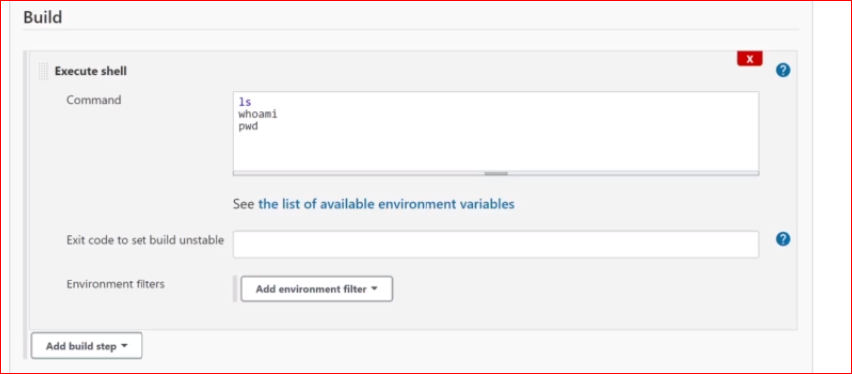

Click on build now

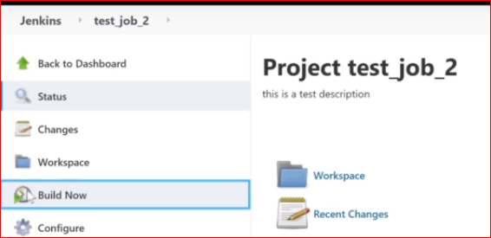

See the output in console

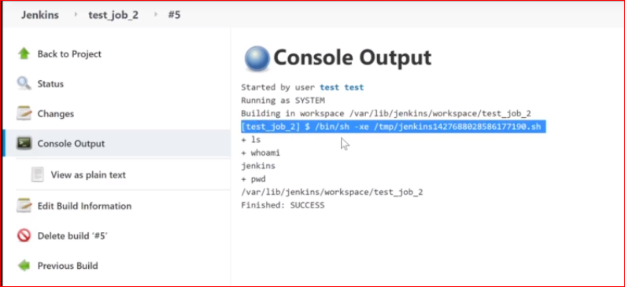

In build section we can add bunch of command example

we want to run deploy | run apache | start nginx | run Django unicore | start service and so on

execute command and specific scripts | or to execute docker command to run docker container or run whatever we run in terminal we can add that part command or script in BUILD >> execute shell dropdown

there are lot of thing we have to do R and D for each menu about how to and script to put in this job

==========================JOB POST BUILD ACTIONS ======================================

AFTER the build is complete we can have post build actions

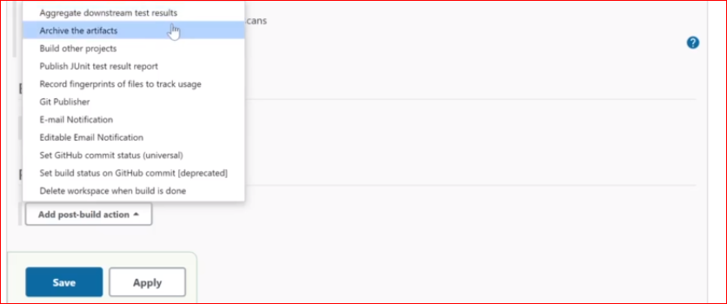

Artifact will generated when completed Jenkins build or whatever

Build other projects if you want other project to be build

We can email notification AND MUCH MORE………….

================================= JOB VIEW ===========================================

WHAT IF WE HAVE MULTIPLE jobs and I don’t want all the jobs to show here in ALL TAB

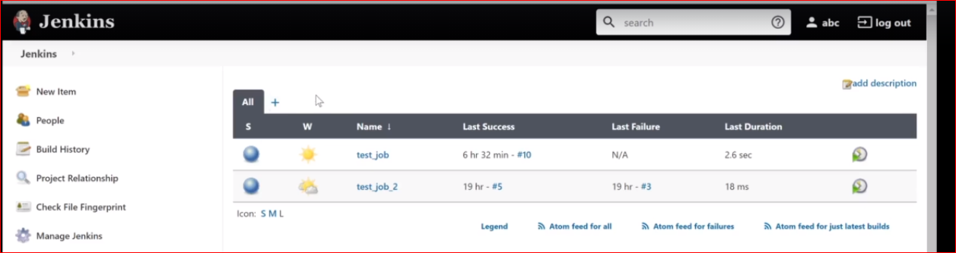

We can create view by below plus button

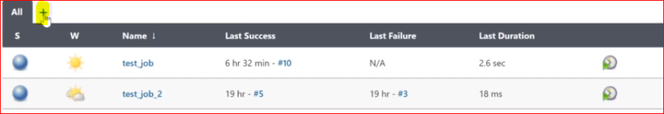

Creating first view using list view

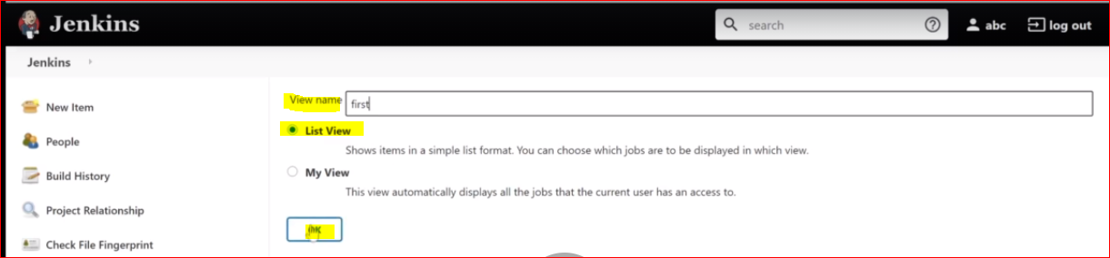

Select specific jobs and press ok >> It will display specific selectd jobs in first list view and press ok

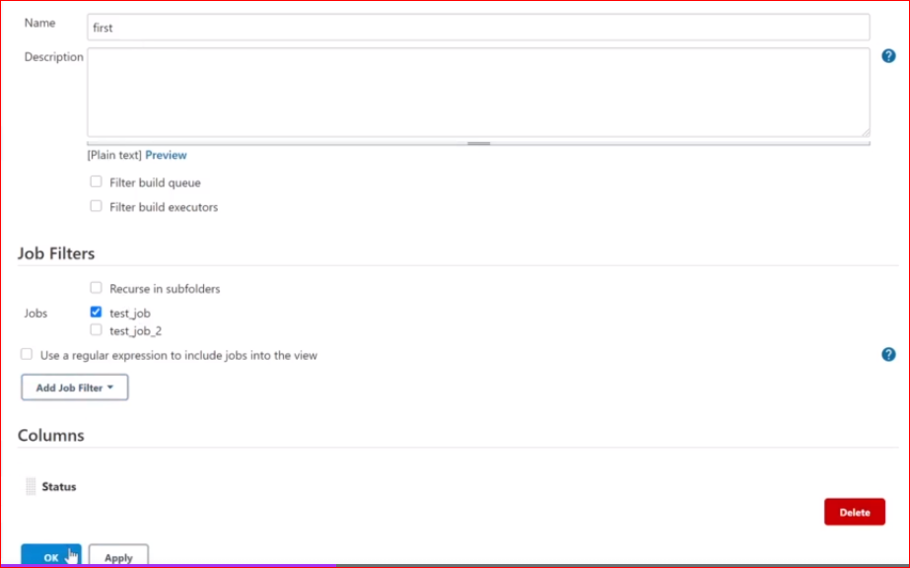

Creating second view and add 2nd job and press ok

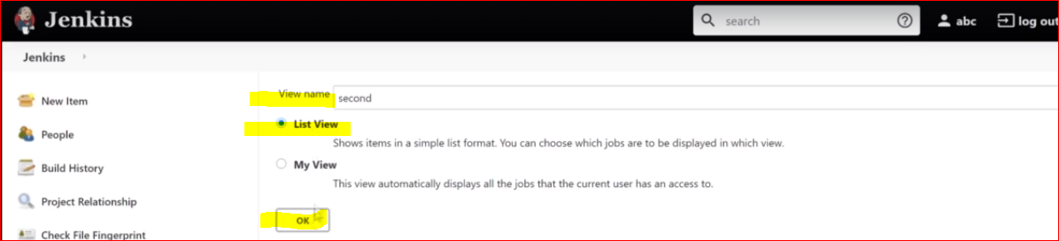

In second Tab test_job2 will display

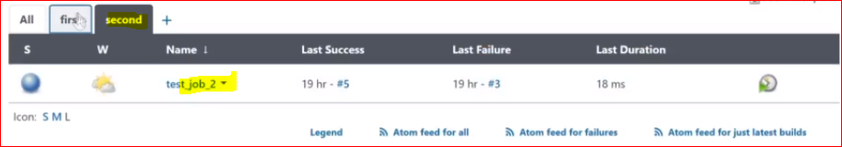

In first tab test_job will display

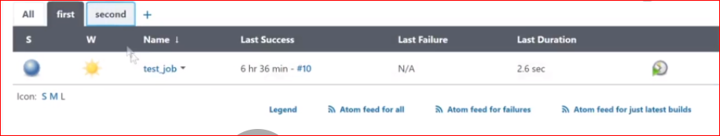

In All TAB all jobs are displayed

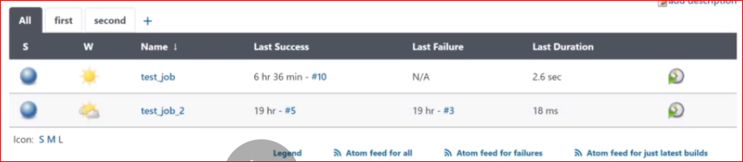

============Jenkins Managements System Information ============================